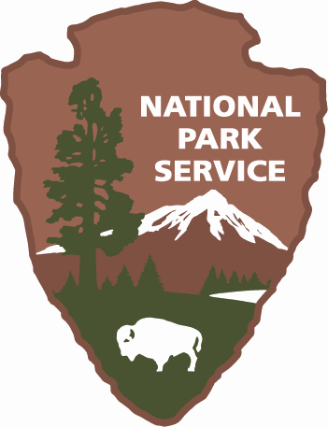
Application for Assistance

Name of Land Trust:
Primary Contact and title:
Mailing Address:

Phone:
Email:

Service Area (list counties):
Number of Staff/Volunteers:
Number of Board Members:
Land Trust Mission:

Background Information:

- Please describe why you are interested in this opportunity and how it will assist you in your conservation efforts (300 words)

- Please describe the landscape in your service area (dominant habitat type(s) and/or land use(s) - forest, agriculture, extraction, etc., degree of fragmentation, major protected areas, other important features or influences). (300 words)

- What is your vision for conserving this landscape? Where do you feel your land trust needs the most assistance to achieve this vision (relevant to this opportunity)? (200 words)

- We encourage broad participation from stakeholders in this process. If your land trust were selected, who might you like to invite (broadly) to the Short Course, the Visioning and Mapping process, and/or the Funding and Implementation charrette? (staff, board members, other conservation groups, local officials, biodiversity experts, landowners, etc.).

The following questions will allow us to better understand your background in biodiversity conservation and the challenges you face:

- How much have you engaged in biodiversity conservation to date? Please describe. If you have not, why not and what is your interest in doing so? (150 words)?

- Do you have a land protection plan that includes biodiversity as an element and does it align with any local, state or regional conservation plans? Does it contain conservation priority area maps, and if so, how were they derived? If you do not have a land protection plan, how have you typically evaluated conservation opportunities? (150 words)

- What are the most pressing conservation challenges in your service area? What other groups in your area are working to address these challenges and how are you partnering with them? (150 words)

- Staff and funding aside, what have been your biggest challenges, as a land trust, in achieving your resource conservation goals and how will this opportunity help you to address those challenges? (150 words)

- Other comments:

Logistical Considerations:

- Can your staff and a representative number of board members commit to 3 full days for the first portion (course and mapping) and an additional day for the funding and implementation charrette? At least this level of participation is required to qualify for the grants. Date and location to be determined with the selected land trust(s).

- Are there any specific biodiversity-related topics that you are most interested in learning about (from those listed or additional topics)?

Please fill out and email this application by October 15, 2008 to:

Alli Barra Srinivas
Land Conservation Coordinator
asrinivas@defenders.org

Questions? Call: Aimee Weldon at 202-772-3265

This project is supported through a grant from the National Fish and Wildlife Foundation
and the many contributions of our partners

